Intro to JavaScript’s Asynchronous Nature

Abstract

JavaScript is a single threaded language originally used for client side scripting . With development in both technology and other advancements ,modern apps have evolved to require more performance , real time issues along with scalability issues in which synchronous style was found limited. Node.js extends JavaScript to the server side and heavily relies on asynchronous, non-blocking architecture to achieve scalability and responsiveness. This document focuses on the need of asynchronous programming in javaScript and how it helps in resolving issues with current synchronous javaScript without violating it’s nature of single- threaded.

Introduction

JavaScript is one of the most popular languages in the web development even popular by modern standards. It’s nature is synchronous which means it run codes line by line or saying in simpler terms doing one work at a time. This mode of operation is approachable method for simple development .However , with modern applictions with huge complexity and it’s scale , the synchronous nature isn’t suitable. It cretes problems when handling issues realed to time such as file access, network interactions and other database interactions.
For example:
- Making HTTP requests using fetch()
- Accessing a user's camera or microphone using getUserMedia()
- Asking a user to select files using showOpenFilePicker()

Node.js is a JavaScript runtime environment that allows JavaScript to be executed outside the browser, primarily on servers.Node js is popular for using an event driven, non blocking I/O model. This approach makes asynchronous programming an essential for scalbility and performance. Not using asynchronous mechanisms might lead to poor user interfaces throughout the system along with poor throughput. Therefore, understanding the role and necessity of asynchronous programming is crucial for effective JavaScript and Node.js development.

Synchronous Nature of JavaScript
In a synchronous execution following are key things happening:
- Each statement waits for the previous one to finish.
- Long-running operations block the main thread.
- The user interface becomes unresponsive during blocking tasks.

A simple example is depicted below:

const name = "Miriam";
const greeting = `Hello, my name is ${name}!`;
console.log(greeting);
// "Hello, my name is Miriam!"
This code:
- Declares a string called name.
- Declares another string called greeting, which uses name.
- Outputs the greeting to the JavaScript console.
Here in this mini example we can observe that the browser runs code synchronously,i.e one at a time in order top to below. The problem with synchronous is better explained by 2nd example below
HTML
<label for="quota">Number of primes:</label>
<input type="text" id="quota" name="quota" value="1000000" />

<button id="generate">Generate primes</button>
<button id="reload">Reload</button>

<div id="output"></div>

JS
const MAX_PRIME = 1000000;

function isPrime(n) {
for (let i = 2; i <= Math.sqrt(n); i++) {
if (n % i === 0) {
return false;
}
}
return n > 1;
}

const random = (max) => Math.floor(Math.random() * max);

function generatePrimes(quota) {
const primes = [];
while (primes.length < quota) {
const candidate = random(MAX_PRIME);
if (isPrime(candidate)) {
primes.push(candidate);
}
}
return primes;
}

const quota = document.querySelector("#quota");
const output = document.querySelector("#output");

document.querySelector("#generate").addEventListener("click", () => {
const primes = generatePrimes(quota.value);
output.textContent = `Finished generating ${quota.value} primes!`;
});

document.querySelector("#reload").addEventListener("click", () => {
document.location.reload();
});
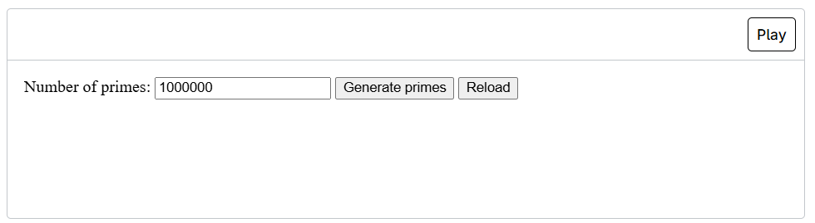

From the above example when clicking generate primes. It takes some seconds before giving result.
Heres another example depicting the limitation of synchronous .

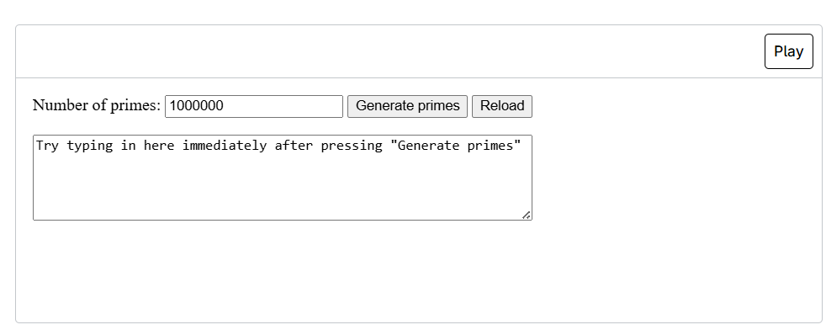

This is similar to the previous example with addition of other area for typing. After clicking on generate primes then typing immediately , users find that it freezes or is unresponsive. This is because of synchronous nature in which the previous function must be completed before other one has to run.

Need of Asynchronous

Heres what our function need to do for smooth execution without delays and problems:
- A long running application must be called using a function.
- We need to have that function start the operation and return immediately, so our program can be responsive to other events.
- There must be other function to handle the execution in such a way that it mustn’t block the other code .
- Notify the developer with result of operation when it completes
This is what asynchronous function allow us to do.

How JavaScript handles asynchronous function

Asynchronous execution is achieved through runtime rather than multi threading in javascript.

Components in Asynchronous Js
Js Engine
Js engine such as V8 in Chrome and Node is the one responsible for running the actual code.the engine consistes of
- Heap
- Call Stack
Call Stack
The call stack is a data structure that keeps track of function calls during program execution. The order of execution in call stack is in LIFO format(Last In First Out). Function are executed synchronously; i.e. one at a time here.
When a function is called it is pushed in the stack. Once execution finishes, it is popped off the stack. If a long-running function blocks the stack, no other code can execute. Thus, the need of asynchronous arises.
Heap
Heap is used for dynamic memory allocation. It is a region to store objects, functions, and variables. It doesn’t directly handle asynchronous execution.
Web APIs
Web APIs are provided by the browser and are not part of the JavaScript engine itself. They allow JavaScript to perform tasks that take time to complete.
Examples include:
- setTimeout and setInterval
- DOM event handling
- HTTP requests (fetch)
- Geolocation
- Web storage
When Js invokes a Web API, the operation is offloaed into the browser. Once completed, the associated callback is placed in the call back or microtask queue.
This allows JS to execute its operation without blocking the call stack.
Node.js APIs (Server Environment)
In Node.js, asynchronous operations are handled by Node APIs, which interact with the underlying operating system. Examples include:
- File system operations
- Network requests
- Database access
- Timers
Node.js uses an internal library called libuv to manage asynchronous I/O operations using an event-driven, non-blocking model.This architecture enables Node.js to handle thousands of concurrent connections efficiently using a single thread.
CallBack Queue
The callback queue stores callback functions that are ready to be executed after their asynchronous operations complete.
Typical sources of callbacks in this queue include:
- Event handlers (click, input, load)
- setTimeout and setInterval
- Completed I/O tasks
Callbacks in this queue wait until the call stack becomes empty before being executed.
Microtask Queue
It is a higher priority queue mostly use for promises, queue microtasks.
Microtasks are executed immediately after the current execution context, before any tasks in the callback queue. This ensures faster handling of Promise-based asynchronous operations.

Asynchronous Techniques used in Js
CallBack
A callback is a function passed as an argument to another function and executed after an asynchronous task completes.
Callbacks are widely used in:
- Timers (e.g., setTimeout)
- Event handlers
- I/O operations
Callback hell is another popular term used in this fiel which is nesting of these fucntions and a necessity to reduce.
Event Handlers as Callbacks
Event handlers are a special type of callback function that execute in response to user or system events such as clicks, key presses, or page loading. When an event occurs, the browser places the corresponding event handler into the callback queue, and it is executed once the call stack is free.
Promises
Since call back has some limitations, promises were introucted to mitigate such limitations.
A promise represents a value that may be in the present, in future or never. When a Promise is resolved or rejected, its handlers are placed in the microtask queue, which is processed before the callback queue. This prioritization ensures faster and more predictable execution compared to traditional callbacks. Promises significantly reduce callback nesting and improve the structure of asynchronous code.
Async await
It’s like a modern syntax approach of asynchronous programming of promises. The async keyword is used with a function that returns promise, while await pauses execution within tht function until it is executed. The mechanism used here is event loop .

Event Loop

The event loop is what makes Node.js non-blocking and efficient. It handles asynchronous operations by delegating tasks to the system and processing their results through callbacks, allowing Node.js to manage thousands of concurrent connections with a single thread.
Node.js follows these steps to handle operations:
- Execute the main script (synchronous code)
- Process any microtasks (Promises, process.nextTick)
- Execute timers (setTimeout, setInterval)
- Run I/O callbacks (file system, network operations)
- Process setImmediate callbacks
- Handle close events (like socket.on('close'))
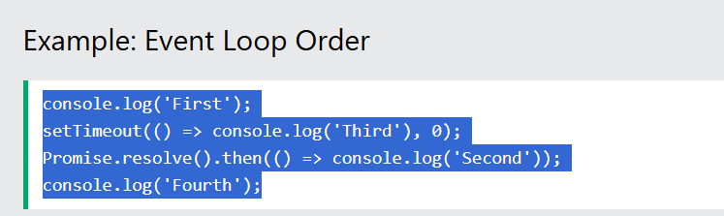

- Sync code runs first ('First', 'Fourth')
- Microtasks (Promises) run before the next phase ('Second')
- Timers execute last ('Third')

Helpful Links
- https://developer.mozilla.org/en-US/docs/Learn_web_development/Extensions/Async_JS/Introducing
- https://archive.org/details/node.js-express-mongo-db-more-the-complete-bootcamp-2021/%5BTutsNode.com%5D+-+Node.js%2C+Express%2C+MongoDB+%26+More+-+The+Complete+Bootcamp+2021/08+Using+MongoDB+with+Mongoose/085+Creating+Documents+and+Testing+the+Model.mp4
- https://www.w3schools.com/nodejs/

